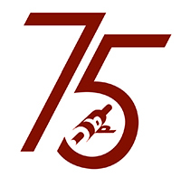
Boston Printmakers Scholarship Opportunity

SUMMER 2021
APPLICATION DEADLINE JANUARY 16, 2021
APPLY ON LINE!

ANDERSON RANCH ART CENTER
Snowmass, Colorado | www.andersonranch.org

Professional Scholarship
The Boston Printmakers and Anderson Ranch team to offer a special summer scholarship for a fabulous one-week professional workshop in printmaking at beautiful Anderson Ranch.
Study with noted professional printmakers and learn new techniques! This award covers FULL tuition and a cash stipend of $500 from The Boston Printmakers toward your travel, housing or other costs of the workshop.

Details of the printmaking workshops from which to choose. Please complete the online application for your chance to attend Anderson Ranch in Summer 2021!
The awardee will be chosen by lottery: receipt deadline is Jan. 16. Notification is by Jan. 17!

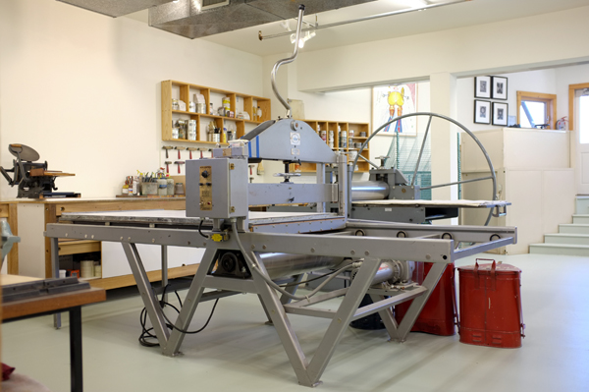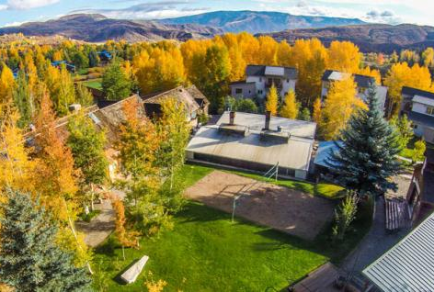
Please read the accommodation information for summer workshops.

Applicants must select preferred workshops, ANY OF WHICH YOU ARE WILLING TO ATTEND.
The recipient’s actual enrollment will be done directly with Anderson Ranch.

Note: The Ranch may need to change some workshops due to cancellation or other reasons, so final arrangements are made by the applicant directly with Anderson Ranch.

Your application to this program constitutes a commitment to accept the grant if chosen, and to participate in the summer workshop. Application receipt deadline: January 16, 2021.
Notification of awardee and runners-up will be by January 17.

2021 ANDERSON RANCH Course listings
R0101-21 June 7 – 11: Monotype, Drypoint & Collagraph, Derick Wycherly
R0303-21 June 21 – 25: Experimental Etching on Copper: texture & surface, Ben Beres
R0404-21 June 28 – Jul 2: Experiments in Papermaking, Kelly Taylor Mitchell
R0505-21 July 5 – 9: Expressive Image Making through Silkscreen, Drew Bennett
R0706-21 July 19 – 23: Hand Drawn Letterpress Plates and Monoprints, Amber Heaton
R0807-21 July 26 – 30: Mono Matrix: Analog and Digital, Emily Ginsberg
R0908-21 Aug 2 – 6: Artist’s Books: bound monotypes, Aurora De Armendi
R1009-21 Aug 9 – 13: Textile Surface Design, Padma Rajendran
R1110-21 Aug 16 – 20: Print Blitz!: alternative screen printing methods, John Hitchcock. ​
R1211-21 Aug 23 – 27: Investigational Monoprint: laser-engraved plexiglass plates (Fab Lab), Susan Belau
R1312-21 Aug 30 – Sept 3: Watermedia Monotype, Brian Shure
R1413-21 Sept 6 – 10: Carving Away Woodcut Reductions, Karen Kunc
R1514-21 Sept 13 – 24: Mixed Media Printmaking, Laura Berman

Any questions about the Anderson Ranch Printmaking Program itself, or the residence, meals or facilities, should be directed to info@andersonranch.org

Questions about The Boston Printmakers award should be directed to Deborah Cornell, dcornell@bu.edu

APPLY TODAY!

2021 Health and Safety information:
Anderson Ranch is committed to the health and safety of all summer workshop participants. Additional protocols include face coverings and daily wellness checks, reduced workshop size and individual art supplies, physical distancing and dedicated studio space, hand washing stations, open doors and windows and a rigorous cleaning schedule. For more details and the full safety plan.

